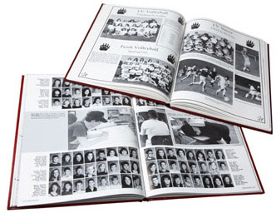

Purchase your

WOODLAND ELEMENTARY YEARBOOK
On Sale Now!!

Place your order NOW for a 68-page, soft-bound,
COLOR yearbook featuring photo memories
of the 2019-2020 school year.

Books now on sale ONLINE only:
ybpay.lifetouch.com
School ID: 11851720

"Early Bird" Pricing: $20 through Monday, April 13th
No late orders (after April 13) will be accepted online, however orders can still be placed and a copy will be reserved for your child. Early bird pricing will still apply for orders placed before May 15.

A limited number of yearbooks will be available for sale in the office
for $25 once they have been received (late May/early June).

* 4th graders do not need to order a yearbook. They will receive one free of charge.

